Tasks To Be Performed:

1. Create an Elastic Beanstalk environment with the runtime as PHP.

2. Upload a simple PHP file to the environment once created.

1. **Create an Elastic Beanstalk environment with the runtime as PHP.**

Go to beanstalk > create app

## 1)Configure environment

## Environment tier> Web server environment

## Application information> Application name(tstphpapp)

## Environment information > Tstphpapp-env ( auto generate)

* Domain > kartestphp
* Platform > PHP (chose language to write code)
* Application code > sample ( I will load php sample file again to test )

**2)Configure service access**

* Service access >Create and use new service role
* EC2 key pair > give existing (ass-key)
* EC2 instance profile > created IAM role for ES2 service with full access
* Set up networking, database, and tags
* VPC > default
* Public IP address > check this
* Instance subnets > select all
* Database > no
* Rest all default > next

**3)** Configure instance traffic and scaling

### Root volume (boot device) > general purpose sdd

* Size > 10 GB
* EC2 security groups > default
* Rest all go with default

**4)Configure updates, monitoring, and logging**

### Health reporting > basic

* Managed platform updates > Managed updates > uncheck
* Rest all go with default
* Review and submit

**Configure environment**

## 

## 

## Configure service access

## 

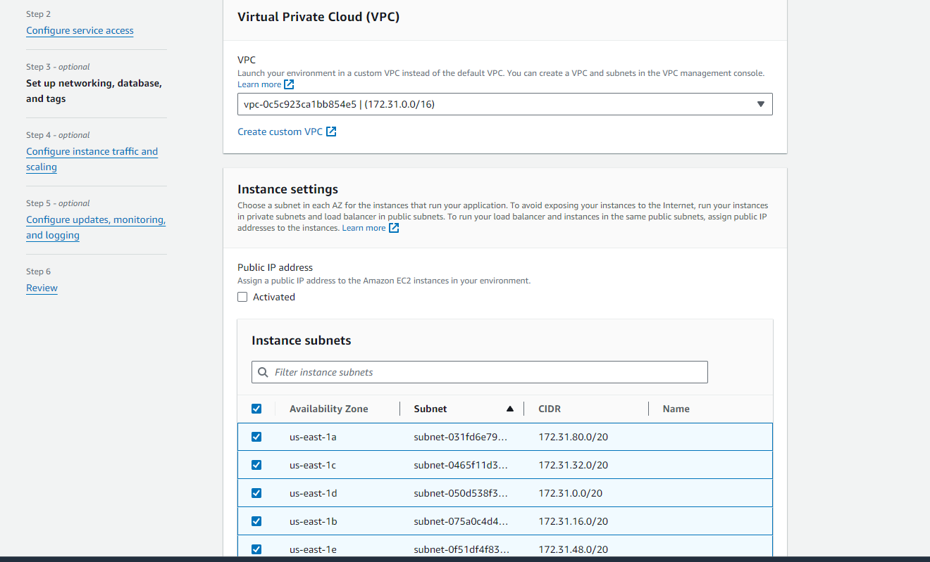

Configure instance traffic and scaling

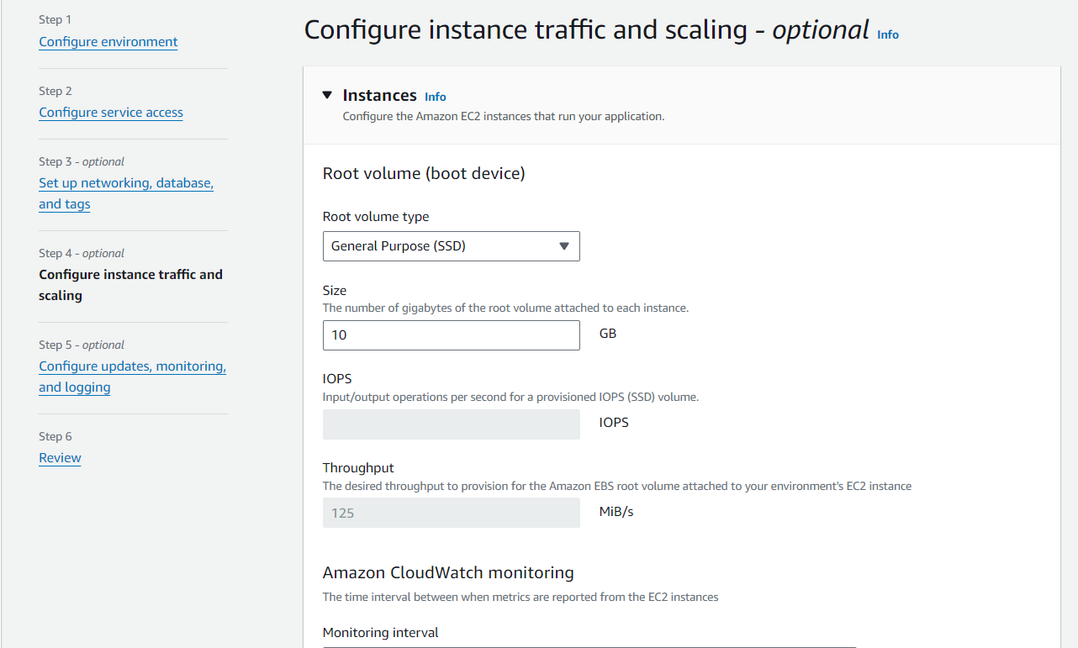

**Configure updates, monitoring, and logging**

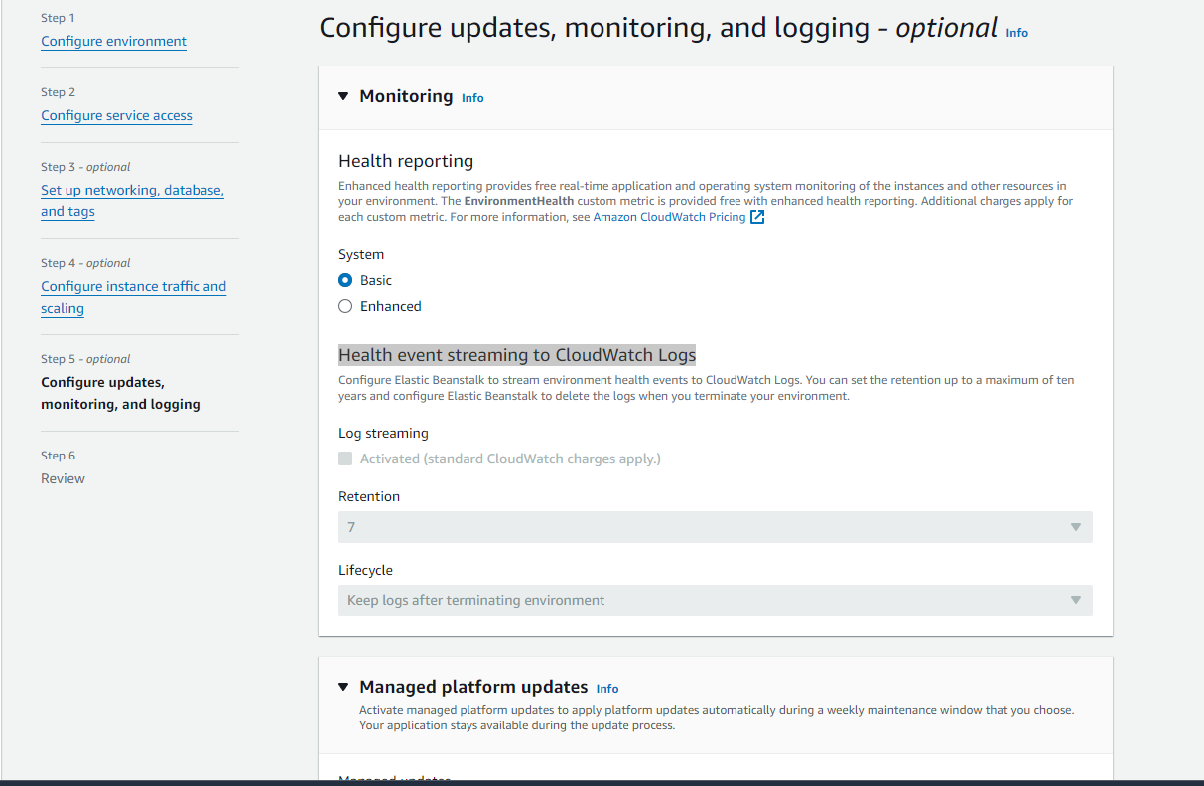

Elastic Beanstalk environment created

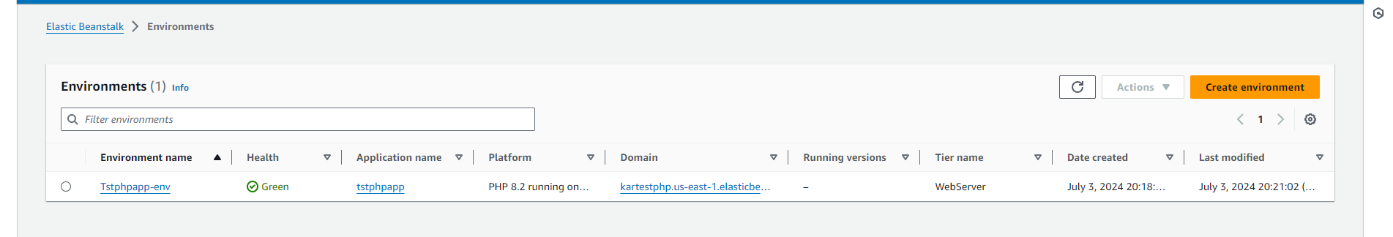

Web page created using AWS sample code

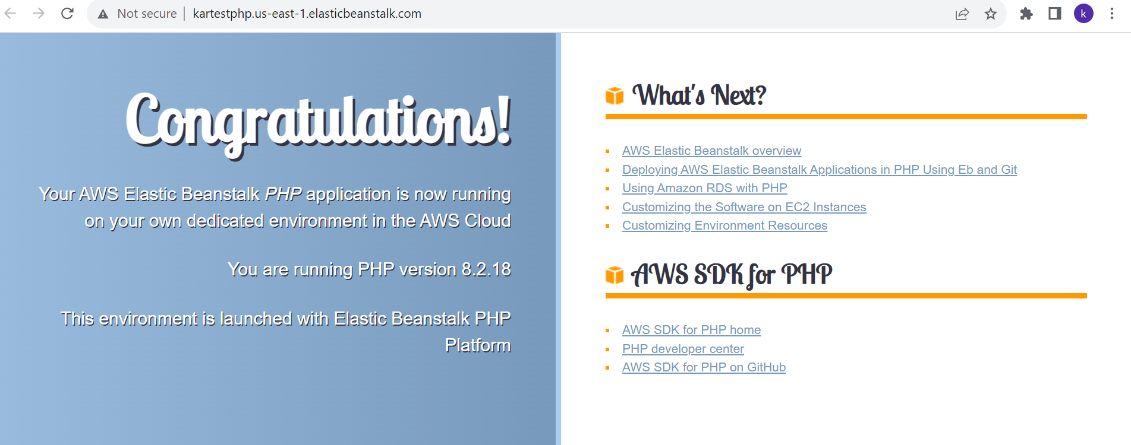

1. **Upload a simple PHP file to the environment once created.**

* Create sample PHP file
* Zip the php file you have created
* Select the Environment you have created
* Go to upload and deploy
* Chose zip sample php file you have created
* Give Version label
* Deploy

<!DOCTYPE html>

<html>

<body>

<h1>My first PHP page</h1>

<?php

echo "Hello World!";

echo "hi this sample page created for BEANSTALK APP";

?>

</body>

</html>

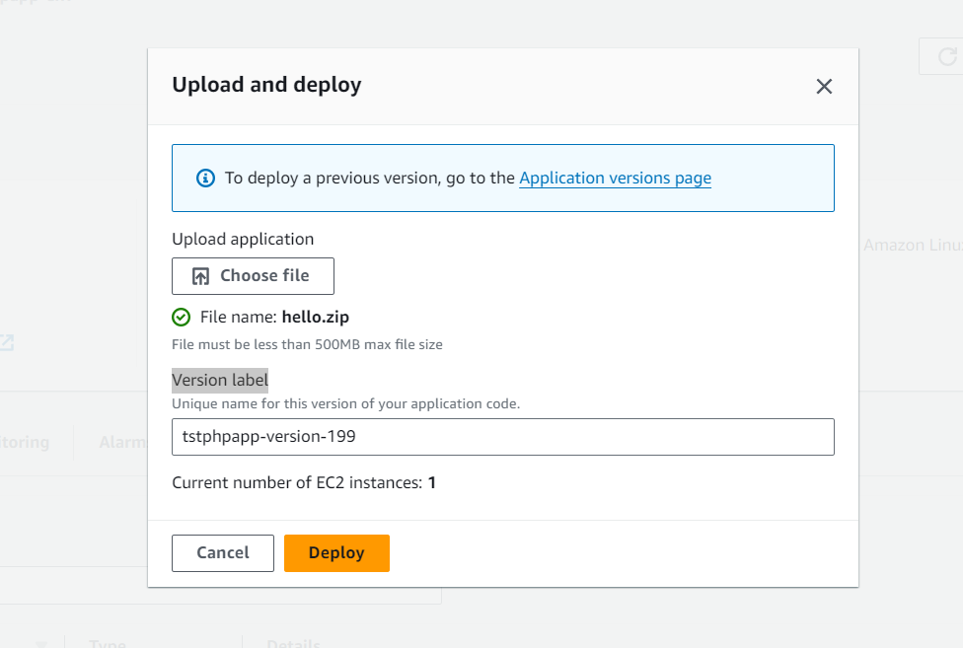

Updated with php file

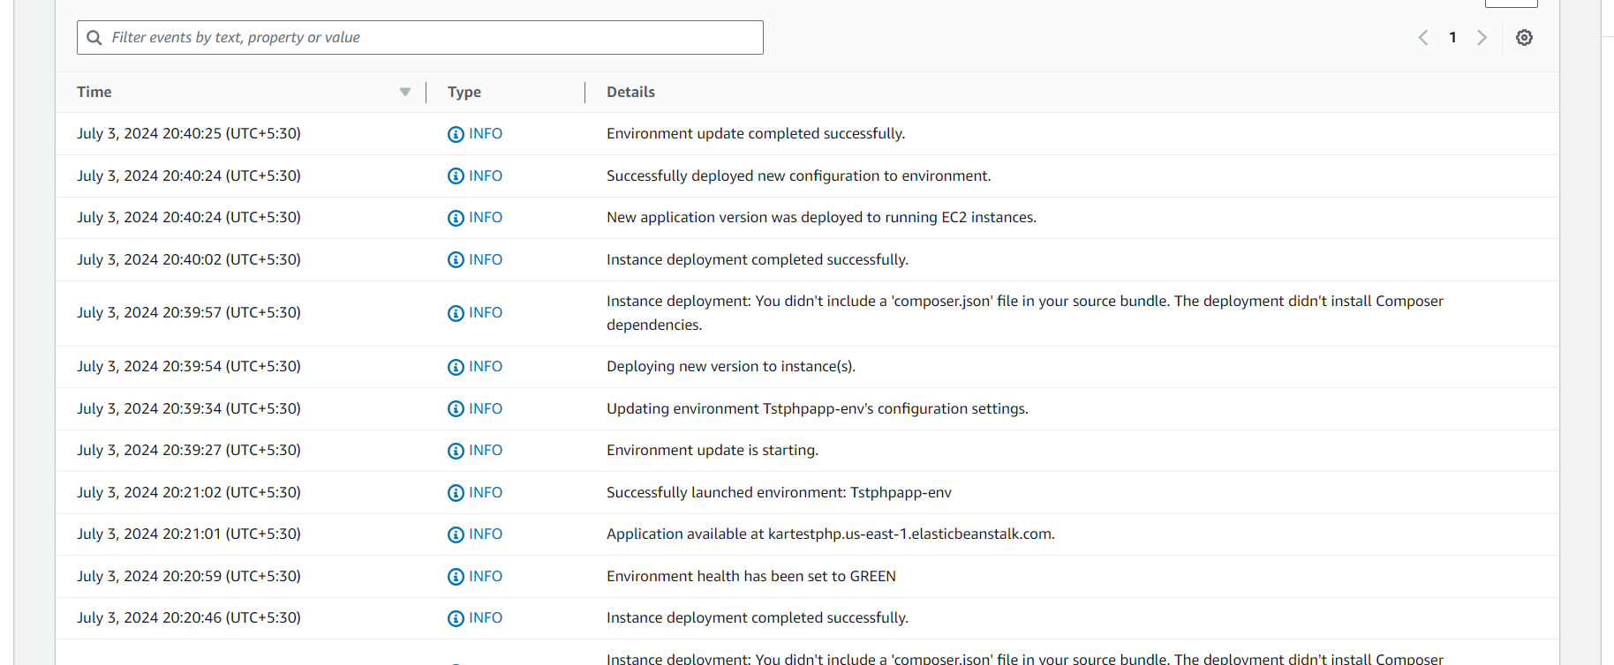

Web page after updating sample PHP

